#116

Customer(s):
TECH Grade Customers  6X7 is usually for customers  receiving product by Rail containers | Customer Supplied Film  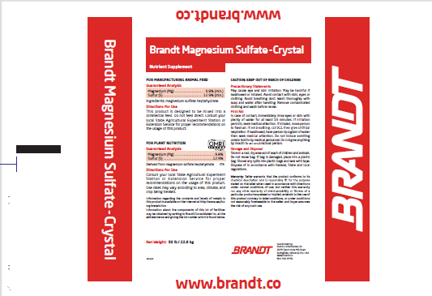
Product: T50P42
- Tech Grade |  | - USP Grade | - Liquid
- Screened 20/60 |  | - Screened 60 | - Other
- Take Samples -

Production / Packaging:
Type of Film - | Customer Supplied Film |  |  |  |  |  | Weight per Bag | 50-lbs
Number of Bags per pallet |  |  | 42 |  | Pallet Configuration |  | 7 per layer X 6 layers
Type of Sacks - |  |  |  |  |  |  | Weight per Bag
- Shrink Wrap - |  | - Date, Time & Lot # on each Bag |  |  |  | - Number and Initial each pallet
- Liners Required - |  | - Bottom Tie Grommets |  |  |  | - Super sack Tags
- Placards or Tags Required - |  |  |  | "6 X 7"
- Stickers Required -
- Other Requirements -

Shipping:
- General - | Load according to Giles loading chart and quantity on Bill of Lading
- Air Bags |  | - Double Wrap | - Corner Boards | -
- Must have Quality Approval before loading |  |  | - Must have Management Approval before loading
- Other - | Load 40' RXR containers according to chart in shipping instructions

Revision History:

Date | Change

